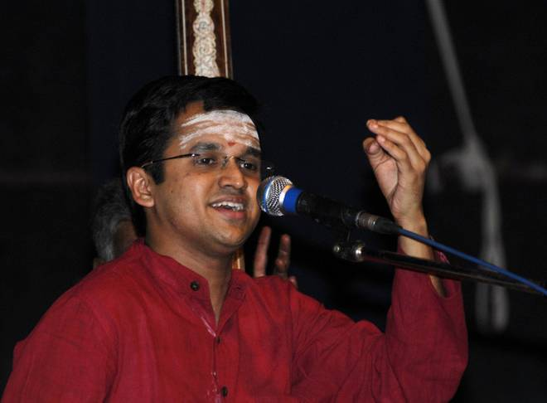

VID. SAKETHRAMAN – VOCAL

